CS 255 System Design Document Template

This template lays out all the different sections that you need to complete for Project Two. Each section has guidance to prompt your thinking. You will need to continually reference the interview transcript as you work to make sure that you are addressing your client’s needs. There is no required length for the final document. Instead the goal is to complete each section based on what your client’s needs are. Remove this note when you are finished, and replace all bracketed text with the relevant information.

UML Diagrams

UML Use Case Diagram
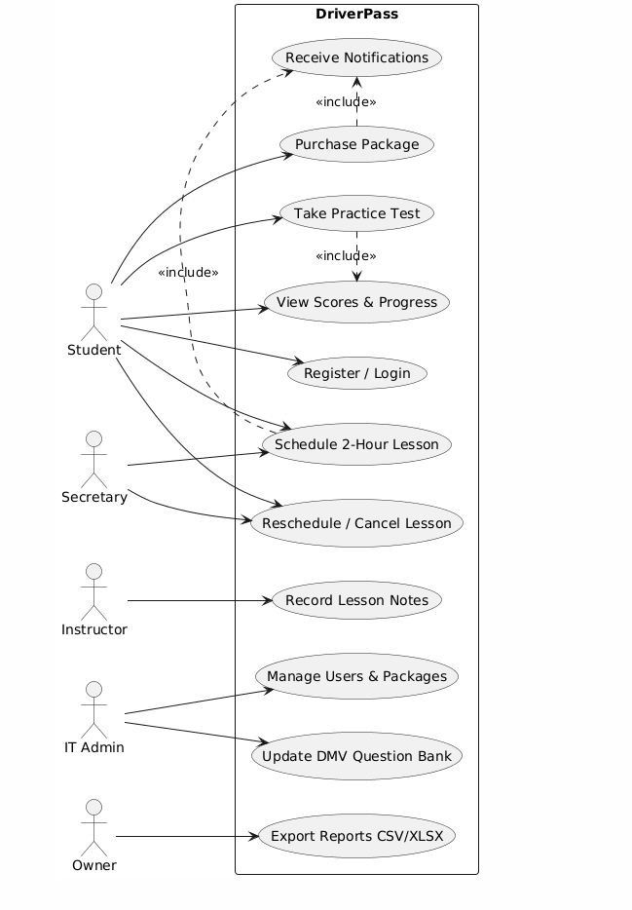

UML Activity Diagrams
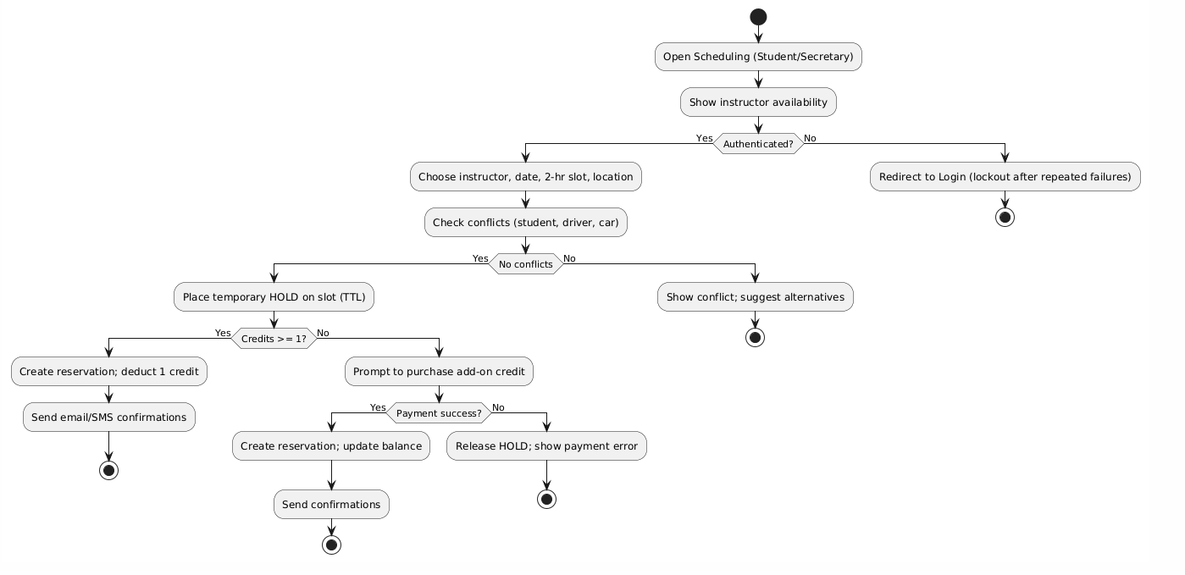

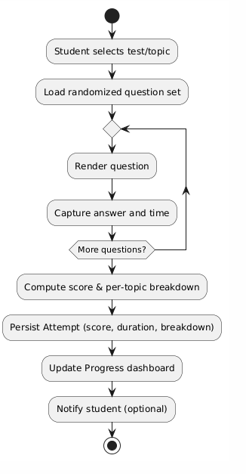

UML Sequence Diagram
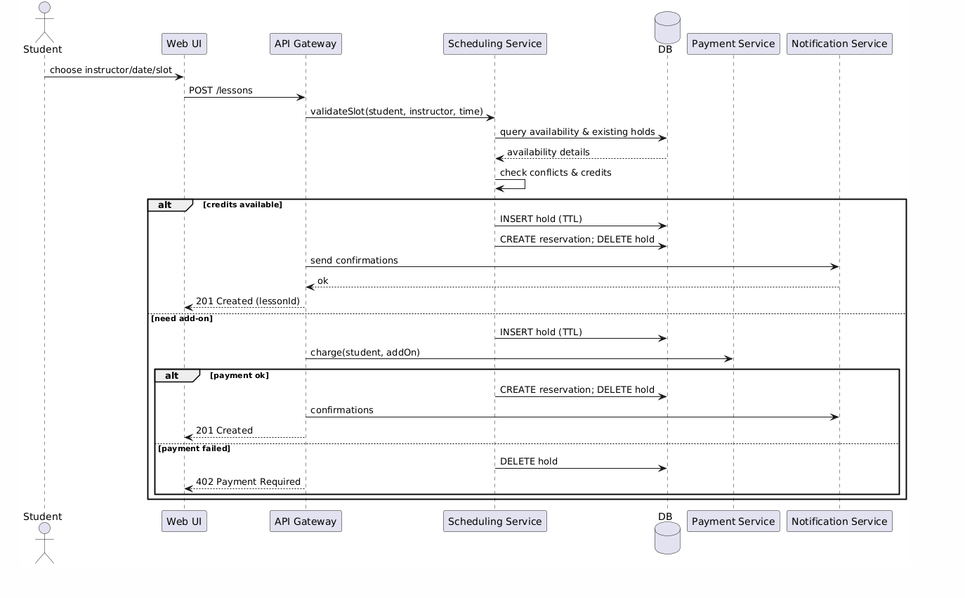

UML Class Diagram
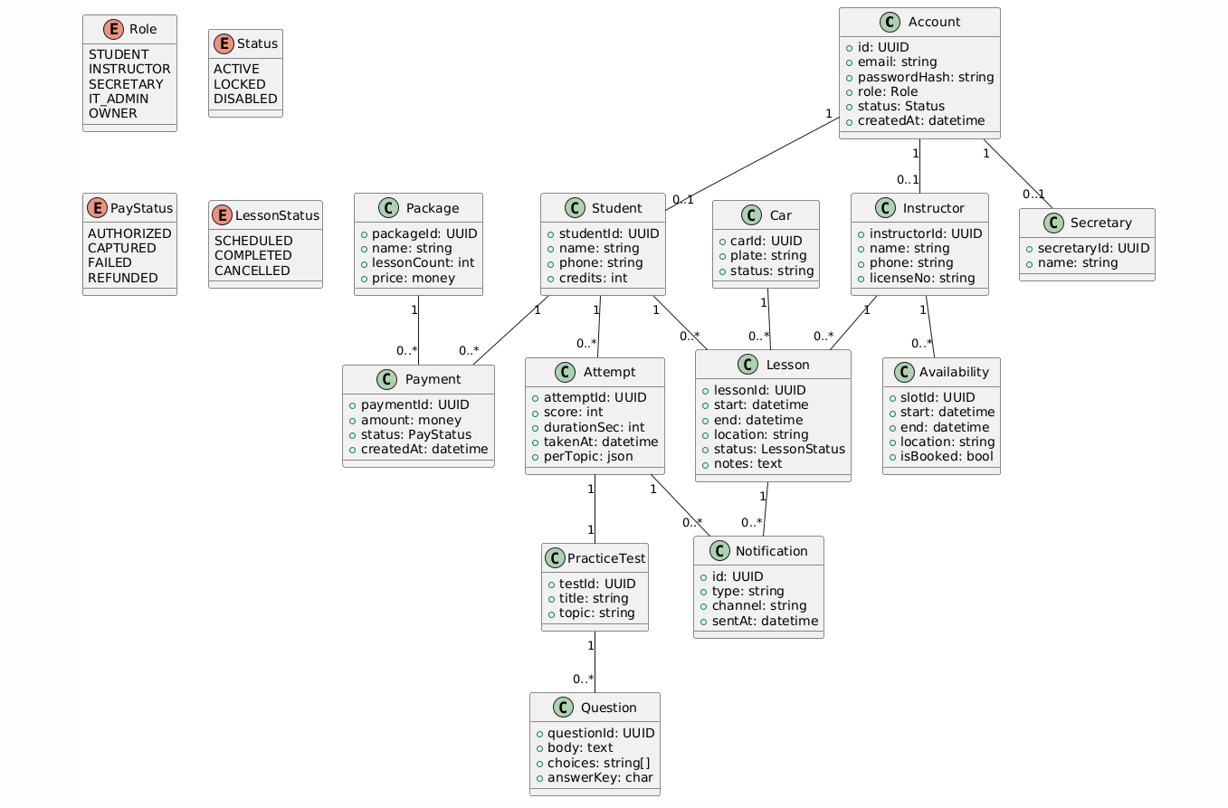

Technical Requirements
The DriverPass system will be built as a three-tier web application consisting of a front end, a back end (API and services), and a database layer. The system design supports scalability, security, and high availability to meet client needs for online lessons, practice tests, and progress tracking.

Hardware Requirements
- Cloud-based hosting environment (e.g., AWS, Azure, or Google Cloud) for on-demand scalability.
- Load-balanced web servers run the application services.
- Cloud relational database servers for persistent data storage (e.g., AWS RDS with PostgreSQL).
- Secure storage for user data, reports, and DMV content (e.g., Amazon S3).
- Network hardware and redundancy managed by the hosting provider to ensure reliability and uptime.

Software Requirements
- Frontend: Developed using React (JavaScript/TypeScript) for a responsive browser interface compatible with Chrome, Edge, Safari, and Firefox.
- Backend: Implemented with Java Spring Boot or .NET 8 Web API to manage scheduling, payments, and authentication.
- Database: PostgreSQL for relational data; Redis for caching and temporary lesson slot holds.
- Payment Integration: Secure external payment processor (e.g., Stripe) for PCI compliance.
- Notification Services: Email/SMS delivery using AWS SES/SNS or Twilio.
- Security: TLS 1.3 encryption, bcrypt password hashing, CSRF protection, and role-based access controls (RBAC).

Tools
- Lucidchart for UML diagrams and system modeling.
- GitHub or GitLab for version control and team collaboration.
- GitHub Actions / Jenkins for CI/CD pipeline automation.
- AWS CloudWatch for monitoring and logging.
- Visual Studio Code / IntelliJ IDEA for development.
- Postman for API testing and validation.

Infrastructure Requirements
- Three-tier architecture:
  - Presentation Layer: Browser-based UI.
  - Application Layer: REST APIs and microservices for core business logic.
  - Data Layer: Centralized relational database with backup and replication.
- Deployment: Dockerized containers hosted on AWS ECS/Fargate behind a load balancer.
- Scalability: Auto-scaling policies to handle increased traffic (e.g., registration surges).
- Availability: Target uptime of 99.9%; automatic failover with multi-AZ deployment.
- Backup and Recovery: Daily incremental backups, point-in-time recovery, and cross-region redundancy.

Summary
This infrastructure ensures the DriverPass system is secure, reliable, and capable of supporting thousands of concurrent users. The design aligns with the functional and nonfunctional requirements identified in the Business Requirements Document, enabling a flexible and scalable platform that can evolve as DriverPass grows.

